# Development and Use of 2-D Phase Flow Solver

By Moatasim Farooque

## Project Objectives:

Develop and use 2D two-phase flow solver to evaluate the drag force on a bubble and effect on velocity profile for a various set of parameters ( Position, bubble size, surface tension)

How the drag force on a particle would change if some of the associated parameters like the initial position of the bubble, its size and surface tension of the fluid are changed.

### Geometry:

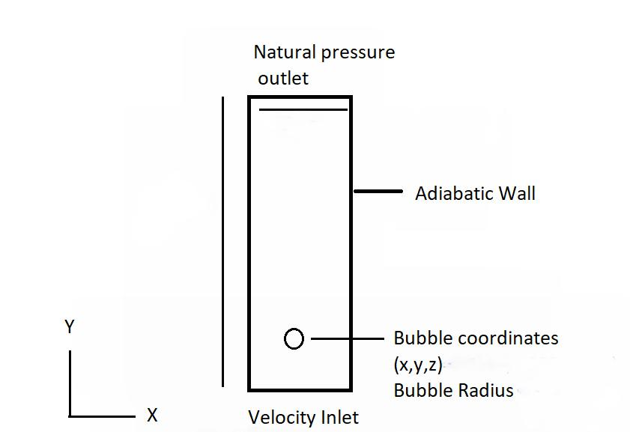

## 

### Validation:

Will try to find a similar case with empirical results available so it can be compared against the simulation results

## Range of Numerical Tests:

The initial coordinates can be chosen to range from x,y=0 to somewhere in the middle of the flow regime. The bubble size can vary from 0.5mm to 5 mm. The surface tension could range between 0.01 to 0.2 N/m

## Final Results:

Plots showing effect of the change in parameters to the drag force magnitude and contours showing the resulting velocity, Pressure profiles